OUTREACH SCHOOLS EXAMINATION BOARD
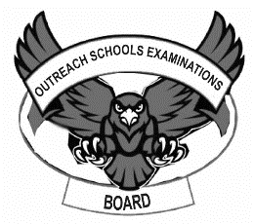
BEGINNING OF TERM III EXAMINATION 2023
PRIMARY TWO
LITERACY 1A

My name is __________________________________________

I am in ______________________________________________

My school is _________________________________________
SECTION A
- Name one living thing in our school compound.
_______________________________________________________
- Give one use of clay to people.
_______________________________________________________
- Draw this item that people make from hides.
drum
- Why do animals move from one place to another?
_______________________________________________________
- Name these building materials.
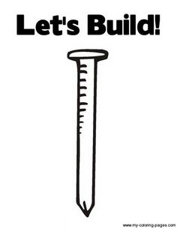 | 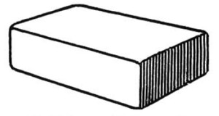

- How can you keep your classroom clean?
_______________________________________________________
- Name one dangerous object in our environment.
_______________________________________________________
- Write two physical activities P.2 pupils can do in the field.
- ___________________________________________________
- ___________________________________________________
- In which season do farmers water their crops?
_______________________________________________________
- How many legs does a spider have?
_______________________________________________________
- Name the young ones of these animals.
- dog __________________________________________
- lion __________________________________________
- Give one way a mother can take care of her baby.
_______________________________________________________
- Identify the food values we get from eating these foods.
 | 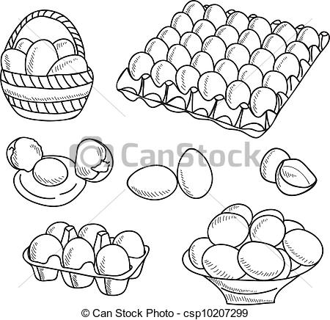

- Why do people bathe everyday?
_______________________________________________________
- Write the type of weather people manage using these items.
- Sunglasses _____________________________________
- Gumboots _____________________________________
- Give one group of people who work in these important places.
- hospital __________________________________________
- police station _____________________________________
SECTION B
- a) Name two common diseases in our homes.
- ___________________________________________________
- ___________________________________________________
b) Write one way of caring for sick people at home.
___________________________________________________
- a) Identify these activities farmers do in the garden.
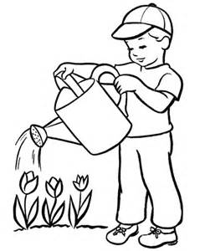 | 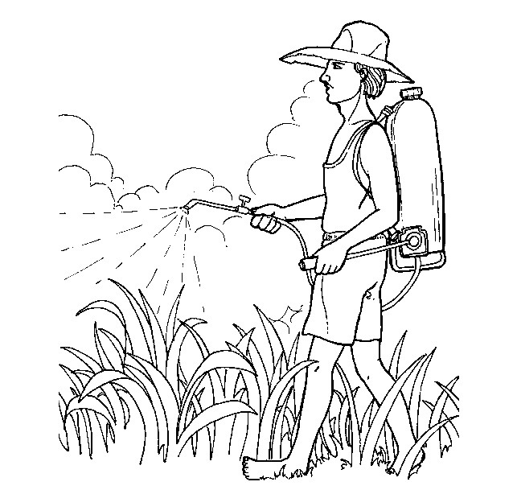

b) Write one thing plants need to grow well.
___________________________________________________
- Name two animals people use for transport.
- _________________________________________________
- _________________________________________________
- (a) Write the use of these garden tools to people.
- Rake
___________________________________________________
- Hoe
___________________________________________________
(b) How can a farmer care for garden tools? ___________________________________________________
- (a) Name this item we use to keep clean.
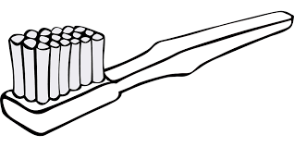

- (a) Match the parts of an insect to their uses.
Parts uses
Spiracles for feeling
Feelers for flying
Wings for breathing
- Spiracles _____________________________________
- Feelers _____________________________________
- Wings _____________________________________
(b) Name one insect that has no wings.
___________________________________________________
- a) Write two items we use to give first aid.
- ___________________________________________________
- ___________________________________________________
b) Why do we give first aid to people who have got
accidents?
___________________________________________________
- a) Name these things we make in our community.
 | 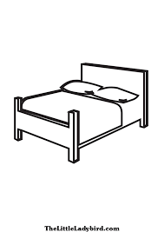
b) Give one use of balls to P.2 children.
___________________________________________________
- a) Write two reasons why we eat food.
- ___________________________________________________
- ___________________________________________________
b) Give one way of keeping cooked food safe.
_________________________________________________
******************* END *******************

